1. assemblies
Represents IFM, PIF, IPU.
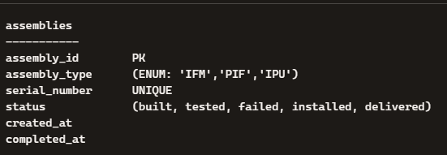
Relationships:
- 1 assembly → many test_events
- 1 assembly → many movements
- 1 IFM → may be installed into 1 PIF
- 1 PIF → may be installed into 1 IPU

2. valves
Tracks every valve and its lifecycle.
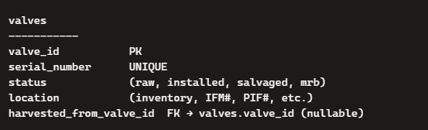
Relationships:
- many valves ↔ many assemblies (via assemblies_parts)
- harvested_from_valve_id supports salvage lineage

3. assemblies_parts
Tracks valve installation/removal from IFMs.
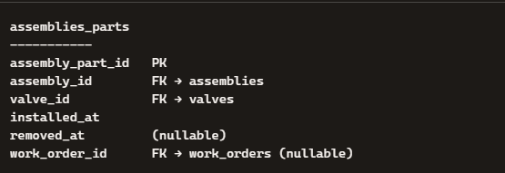
Notes:
- Supports reversible installation
- A valve can be installed/removed multiple times across IFMs

4. assemblies_subassemblies
Tracks IFM→PIF and PIF→IPU installation/removal.
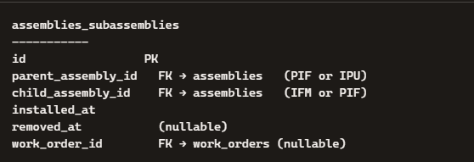
Rules:
- IFM → PIF (reversible)
- PIF → IPU (not reversible; removed_at stays NULL)

5. kits
Represents a kit used to build an IFM.
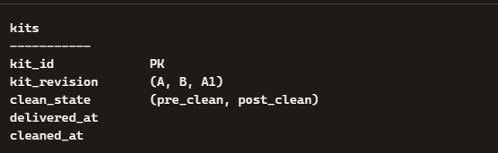

6. kit_parts
Required vs actual kit contents.
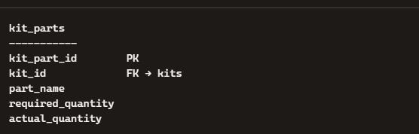

7. test_chambers
Defines MQC and ISTC.
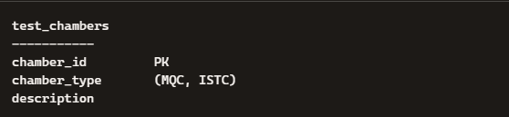

8. test_events
Every MQC/ISTC test.
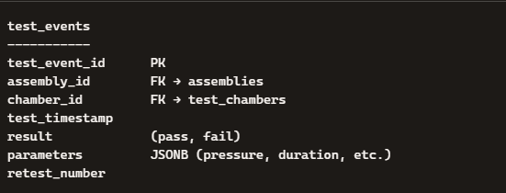
Supports:
- MQC queue
- ISTC queue
- Retest tracking
- Failure analysis

9. movements
Every movement event in the system.
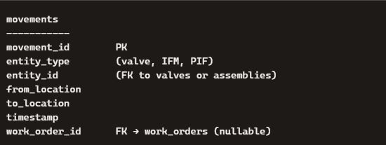

10. work_orders
Generic work order linkage.
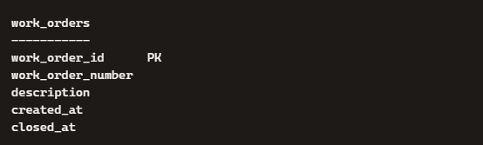

⭐ RELATIONSHIP SUMMARY (High-Level)

Valves
- valves ↔ assemblies (many-to-many via assemblies_parts)
- valves → valves (harvest lineage)

Assemblies
- assemblies_subassemblies creates:
  - IFM → PIF (reversible)
  - PIF → IPU (final)

Kits
- kits → kit_parts (1-to-many)
- kits → assemblies (1-to-1 IFM build)

Testing
- assemblies → test_events (1-to-many)
- test_chambers → test_events (1-to-many)

Movements
- valves → movements (1-to-many)
- assemblies → movements (1-to-many)

